

Occupational Therapy Board of Australia

Registrant Data

Reporting period: 1 July 2016 – 30 September 2016

Table of contents
Introduction 3
Principal Place of Practice 4
1. Registration Type 4
Age Group 5
2. Registration Type and Sub type 5
Gender 6
3. Registration Type 6
4. Percentage 6

Introduction
The role of the Occupational Therapy Board of Australia (the Board) include:
- registering occupational therapists and students
- developing standards, codes and guidelines for the occupational therapy profession
- handling notifications, complaints, investigations and disciplinary hearings
- overseeing the assessment of overseas trained practitioners who wish to practise in Australia, and
- approving accreditation standards and accredited courses of study.
The Board’s functions are supported by the Australian Health Practitioner Regulation Agency (AHPRA). For information about legislation governing our operations see About AHPRA at http://www.ahpra.gov.au/About-AHPRA/What-We-Do/Legislation.aspx.
The Board has analysed its registration data and produced a number of statistical breakdowns about registrants to share with the profession and community. The Board shares these breakdowns regularly.
For more information on occupational therapy registration, please see the Board’s website http://www.occupationaltherapyboard.gov.au/Registration.aspx

Principal Place of Practice
- Registration Type
  - Registration type by principal place of practice
Registration Type | Registration Sub-type | ACT | NSW | NT | QLD | SA | TAS | VIC | WA | No PPP | Total
General |  | 331 | 5,022 | 172 | 3,409 | 1,360 | 273 | 4,415 | 2,553 | 159 | 17,694
Provisional |  | 2 | 14 |  | 5 | 6 | 1 | 9 | 4 |  | 41
Limited | Postgraduate training or supervised practice | 4 | 25 |  | 14 | 2 | 1 | 21 | 11 |  | 78
Non-practising |  | 5 | 132 | 2 | 125 | 66 | 13 | 126 | 101 | 61 | 631
Total |  | 342 | 5,193 | 174 | 3,553 | 1,434 | 288 | 4,571 | 2,669 | 220 | 18,444

  - Registration type by principal place of practice percentages

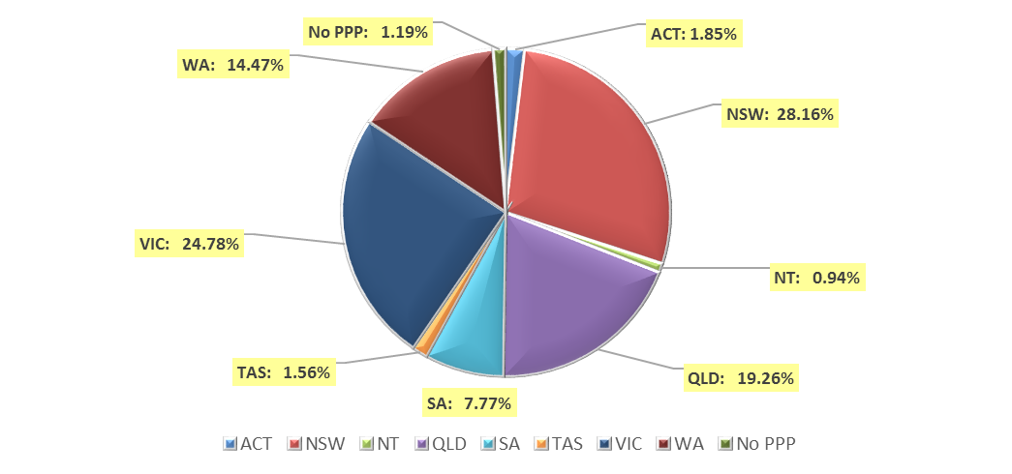

Age Group
- Registration Type and Sub type
  - Registration by age group
Age Group | General | Provisional | Limited | Non-practising | Total
Age Group | General | Provisional | Postgraduate training or supervised practice | Non-practising | Total
U - 25 | 1,601 |  | 2 | 8 | 1,611
25 - 29 | 3,913 | 1 | 21 | 164 | 4,099
30 - 34 | 3,401 | 4 | 25 | 169 | 3,599
35 - 39 | 2,628 | 15 | 15 | 110 | 2,768
40 - 44 | 1,950 | 11 | 7 | 56 | 2,024
45 - 49 | 1,520 | 7 | 4 | 33 | 1,564
50 - 54 | 1,146 | 1 | 3 | 29 | 1,179
55 - 59 | 878 | 2 |  | 25 | 905
60 - 64 | 458 |  | 1 | 21 | 480
65 - 69 | 160 |  |  | 13 | 173
70 - 74 | 36 |  |  | 3 | 39
75 - 79 | 3 |  |  |  | 3
80+
Total | 17,694 | 41 | 78 | 631 | 18,444

  - Registration by age group

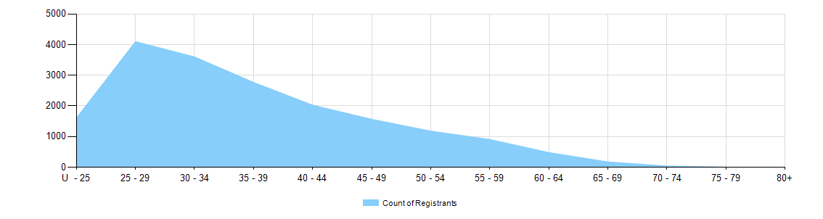

Gender
- Registration Type
  - Gender by state and territory by registration type
Gender | Registration Type | Sub Type | ACT | NSW | NT | QLD | SA | TAS | VIC | WA | No PPP | Total
Female | General |  | 291 | 4,571 | 154 | 3,139 | 1,209 | 248 | 4,057 | 2,342 | 149 | 16,160
Female | Provisional |  | 2 | 14 |  | 5 | 6 | 1 | 8 | 4 |  | 40
Female | Limited | Postgrad training or supervised practice | 4 | 22 |  | 14 | 1 | 1 | 16 | 10 |  | 68
Female | Non-practising |  | 5 | 125 | 2 | 120 | 63 | 13 | 120 | 99 | 58 | 605
Total Female |  |  | 302 | 4,732 | 156 | 3,278 | 1,279 | 263 | 4,201 | 2,455 | 207 | 16,873
Male | General |  | 40 | 451 | 18 | 270 | 151 | 25 | 358 | 211 | 10 | 1,534
Male | Provisional |  |  |  |  |  |  |  | 1 |  |  | 1
Male | Limited | Postgrad training or supervised practice |  | 3 |  |  | 1 |  | 5 | 1 |  | 10
Male | Non-practising |  |  | 7 |  | 5 | 3 |  | 6 | 2 | 3 | 26
Total Male |  |  | 40 | 461 | 18 | 275 | 155 | 25 | 370 | 214 | 13 | 1,571
Total |  |  | 342 | 5,193 | 174 | 3,553 | 1,434 | 288 | 4,571 | 2,669 | 220 | 18,444

- Percentage
  - Registrants by gender percentages
Gender | ACT | NSW | NT | QLD | SA | TAS | VIC | WA | No PPP | Total
Female | 88.3% | 91.1% | 89.7% | 92.3% | 89.2% | 91.3% | 91.9% | 92.0% | 94.1% | 91.5%
Male | 11.7% | 8.9% | 10.3% | 7.7% | 10.8% | 8.7% | 8.1% | 8.0% | 5.9% | 8.5%

