

Occupational Therapy Board of Australia

Registrant data

Reporting period: 1 April 2018 – 30 June 2018

Table of contents
Introduction 3
Principal place of practice 4
1. Registration type 4
Age Group 5
2. Registration type and subtype 5
Gender 6
3. Registration type 6
4. Percentage 6

Introduction
The role of the Occupational Therapy Board of Australia (the Board) includes:
- registering occupational therapists and students
- developing standards, codes and guidelines for the occupational therapy profession
- handling notifications, complaints, investigations and disciplinary hearings
- overseeing the assessment of overseas trained practitioners who wish to practise in Australia, and
- approving accreditation standards and accredited courses of study.
The Board’s functions are supported by the Australian Health Practitioner Regulation Agency (AHPRA). For information about legislation governing our operations see About AHPRA at http://www.ahpra.gov.au/About-AHPRA/What-We-Do/Legislation.aspx.
The Board has analysed its registration data and produced a number of statistical breakdowns about registrants to share with the profession and community. The Board shares these breakdowns regularly.
For more information on occupational therapy registration, please see the Board’s website www.occupationaltherapyboard.gov.au/Registration.aspx

Principal place of practice
- Registration type
  - Registration type by principal place of practice
Registration type | Registration subtype | ACT | NSW | NT | QLD | SA | TAS | VIC | WA | No PPP | Total
General |  | 359 | 5,723 | 179 | 3,923 | 1,568 | 304 | 5,123 | 2,833 | 237 | 20,249
Provisional |  |  | 3 |  |  |  |  | 2 |  |  | 5
Limited | Postgraduate training or supervised practice | 3 | 23 | 1 | 5 | 6 | 2 | 16 | 8 |  | 64
Limited | Teaching or research | 1 |  |  |  |  |  |  |  |  | 1
Non-practising |  | 6 | 132 | 2 | 151 | 57 | 7 | 126 | 102 | 73 | 656
Total |  | 369 | 5,881 | 182 | 4,079 | 1,631 | 313 | 5,267 | 2,943 | 310 | 20,975

  - Registration type by principal place of practice percentages
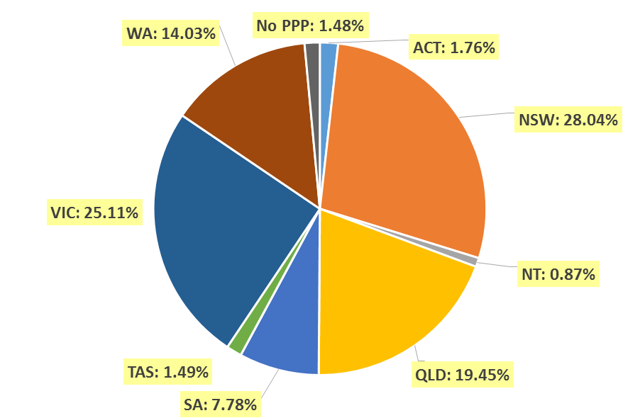

Age Group
- Registration type and subtype
  - Registration by age group
Age group | General | Provisional | Limited |  | Non-practising | Total
Age group | General | Provisional | Postgraduate training or supervised practice | Teaching or research | Non-practising | Total
U - 25 | 2,056 |  | 1 |  | 13 | 2,070
25 - 29 | 4,438 |  | 20 |  | 150 | 4,608
30 - 34 | 3,829 |  | 25 |  | 160 | 4,014
35 - 39 | 2,942 | 1 | 9 |  | 117 | 3,069
40 - 44 | 2,256 | 3 | 6 | 1 | 67 | 2,333
45 - 49 | 1,731 | 1 | 2 |  | 33 | 1,767
50 - 54 | 1,272 |  |  |  | 34 | 1,306
55 - 59 | 924 |  |  |  | 31 | 955
60 - 64 | 554 |  | 1 |  | 31 | 586
65 - 69 | 192 |  |  |  | 15 | 207
70 - 74 | 49 |  |  |  | 5 | 54
75 - 79 | 6 |  |  |  |  | 6
80+
Total | 20,249 | 5 | 64 | 1 | 656 | 20,975

  - Registration by age group

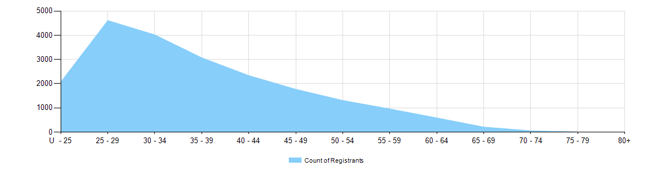

Gender
- Registration type
  - Gender by state and territory by registration type
Gender | Registration type | Subtype | ACT | NSW | NT | QLD | SA | TAS | VIC | WA | No PPP | Total
Female | General |  | 321 | 5,162 | 162 | 3,585 | 1,383 | 270 | 4,708 | 2,600 | 220 | 18,411
Female | Provisional |  |  | 3 |  |  |  |  | 2 |  |  | 5
Female | Limited | Postgrad training or supervised practice | 3 | 21 | 1 | 3 | 5 | 2 | 14 | 8 |  | 57
Female | Limited | Teaching or research | 1 |  |  |  |  |  |  |  |  | 1
Female | Non-practising |  | 6 | 122 | 2 | 143 | 55 | 7 | 113 | 98 | 68 | 614
Total female |  |  | 331 | 5,308 | 165 | 3,731 | 1,443 | 279 | 4,837 | 2,706 | 288 | 19,088
Male | General |  | 38 | 561 | 17 | 338 | 185 | 34 | 415 | 233 | 17 | 1,838
Male | Provisional
Male | Limited | Postgrad training or supervised practice |  | 2 |  | 2 | 1 |  | 2 |  |  | 7
Male | Non-practising |  |  | 10 |  | 8 | 2 |  | 13 | 4 | 5 | 42
Total male |  |  | 38 | 573 | 17 | 348 | 188 | 34 | 430 | 237 | 22 | 1,887
Total |  |  | 369 | 5,881 | 182 | 4,079 | 1,631 | 313 | 5,267 | 2,943 | 310 | 20,975

- Percentage
  - Registrants by gender percentages
Gender | ACT | NSW | NT | QLD | SA | TAS | VIC | WA | No PPP | Total
Female | 89.7% | 90.3% | 90.7% | 91.5% | 88.5% | 89.1% | 91.8% | 91.9% | 92.9% | 91.0%
Male | 10.3% | 9.7% | 9.3% | 8.5% | 11.5% | 10.9% | 8.2% | 8.1% | 7.1% | 9.0%

