Occupational Therapy Registrant Data: March 2013

Published April 2013

Introduction
The functions of the Occupational Therapy Board of Australia include:
- registering occupational therapists and students
- developing standards, codes and guidelines for the Occupational Therapy profession
- handling notifications, complaints, investigations and disciplinary hearings
- assessing overseas trained practitioners who wish to practise in Australia
- approving accreditation standards and accredited courses of study.

The Board’s functions are supported by Australian Health Practitioner Regulation Agency (AHPRA). For information about legislation governing our operations see AHPRA's Legislation & Publications at www.ahpra.gov.au/Legislation-and-Publications.aspx

The Board has analysed its registration data and produced a number of statistical breakdowns about registrants to share with the profession and community. The Board shares these breakdowns regularly.

For more information on occupational therapy registration, please see the Board’s website:
www.occupationaltherapyboard.gov.au/Registration.aspx

Index of Tables
Occupational therapy practitioners: State and territory by registration type 2
Occupational therapy practitioners: Age by registration type 3
Occupational therapy practitioners: Gender by state and territory by registration type 4

Occupational therapy practitioners: State and territory by registration type
State | General | Limited |  | Provisional | Non-practising | Total | % By State
 |  | Postgraduate training or supervised practice | Teaching or research
ACT | 208 | 2 |  |  | 1 | 211 | 1.42%
NSW | 4,037 | 53 |  | 20 | 51 | 4,161 | 27.98%
NT | 126 |  |  |  | 1 | 127 | 0.85%
QLD | 3,061 | 5 | 2 | 1 | 10 | 3,079 | 20.7%
SA | 1,112 | 6 |  | 2 | 68 | 1,188 | 7.99%
TAS | 241 | 6 |  |  | 1 | 248 | 1.67%
VIC | 3,462 | 33 |  | 9 | 41 | 3,545 | 23.84%
WA | 2,197 | 13 |  | 1 | 6 | 2,217 | 14.91%
Not Stated | 86 | 1 |  |  | 8 | 95 | 0.64%
Total | 14,530 | 119 | 2 | 33 | 187 | 14,871

% By state and territory
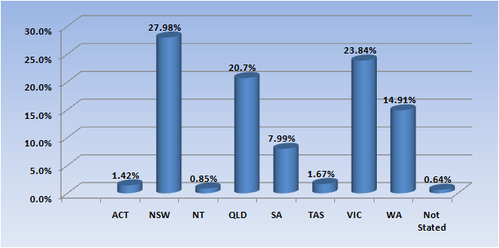

Occupational therapy practitioners: Age by registration type
Age Group | General | Limited |  | Provisional | Non-practising | Total | % By Age Group
 |  | Postgraduate training or supervised practice | Teaching or research
21 - 25 | 1,864 | 14 |  |  | 7 | 1,885 | 12.68%
26 - 30 | 3,263 | 44 |  |  | 51 | 3,358 | 22.58%
31 - 35 | 2,603 | 27 | 1 |  | 61 | 2,692 | 18.1%
36 - 40 | 1,915 | 13 |  | 11 | 35 | 1,974 | 13.27%
41 - 45 | 1,581 | 12 |  | 12 | 14 | 1,619 | 10.89%
46 - 50 | 1,202 | 4 |  | 6 | 6 | 1,218 | 8.19%
51 - 55 | 979 | 3 | 1 | 2 | 4 | 989 | 6.65%
56 - 60 | 680 | 1 |  | 1 | 7 | 689 | 4.63%
61 - 65 | 303 | 1 |  | 1 | 2 | 307 | 2.06%
66 - 70 | 110 |  |  |  |  | 110 | 0.74%
71 - 75 | 20 |  |  |  |  | 20 | 0.13%
76 - 80 | 5 |  |  |  |  | 5 | 0.03%
Not Stated | 5 |  |  |  |  | 5 | 0.03%
Total | 14,530 | 119 | 2 | 33 | 187 | 14,871

% By Age
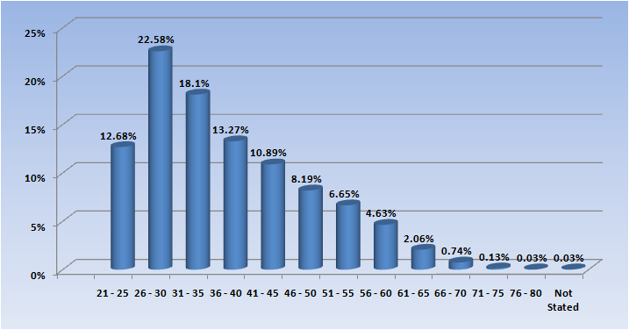

Occupational therapy practitioners: Gender by state and territory by registration type
Sex | State | General | Limited |  | Provisional | Non-practising | Total Count | % By Sex By State
 |  |  | Postgraduate training or supervised practice | Teaching or research
Female | ACT | 185 | 2 |  |  | 1 | 188 | 1.26%
Female | NSW | 3,685 | 51 |  | 19 | 50 | 3,805 | 25.59%
Female | NT | 113 |  |  |  | 1 | 114 | 0.77%
Female | QLD | 2,815 | 5 | 1 | 1 | 10 | 2,832 | 19.04%
Female | SA | 996 | 6 |  | 2 | 65 | 1,069 | 7.19%
Female | TAS | 219 | 5 |  |  | 1 | 225 | 1.51%
Female | VIC | 3,189 | 33 |  | 9 | 40 | 3,271 | 22.01%
Female | WA | 2,021 | 13 |  | 1 | 6 | 2,041 | 13.72%
Female | Not Stated | 80 | 1 |  |  | 7 | 88 | 0.59%
Female | Sub total | 13,303 | 116 | 1 | 32 | 181 | 13,633 | 91.69%
Female | VIC | 2 |  |  |  |  | 2 | 22.01%
Female | Sub total | 2 |  |  |  |  | 2 | 91.69%
Male | ACT | 23 |  |  |  |  | 23 | 0.15%
Male | NSW | 352 | 2 |  | 1 | 1 | 356 | 2.39%
Male | NT | 13 |  |  |  |  | 13 | 0.09%
Male | QLD | 245 |  | 1 |  |  | 246 | 1.65%
Male | SA | 116 |  |  |  | 3 | 119 | 0.8%
Male | TAS | 22 | 1 |  |  |  | 23 | 0.15%
Male | VIC | 271 |  |  |  | 1 | 272 | 1.83%
Male | WA | 170 |  |  |  |  | 170 | 1.14%
Male | Not Stated | 6 |  |  |  | 1 | 7 | 0.05%
Male | Sub total | 1,218 | 3 | 1 | 1 | 6 | 1,229 | 8.26%
Not Stated | QLD | 1 |  |  |  |  | 1 | 0.01%
Not Stated | WA | 6 |  |  |  |  | 6 | 0.04%
Not Stated | Sub total | 7 |  |  |  |  | 7 | 0.05%
Total |  | 14,530 | 119 | 2 | 33 | 187 | 14,871

