

Occupational Therapy Board of Australia

Registrant Data

Reporting period: 1 July 2017 – 30 September 2017

Table of contents
Introduction 3
Principal Place of Practice 4
Registration Type 4
Age Group 5
Registration Type and Sub type 5
Gender 6
Registration Type 6
Percentage 6

Introduction
The role of the Occupational Therapy Board of Australia (the Board) includes:
- registering occupational therapists and students
- developing standards, codes and guidelines for the occupational therapy profession
- handling notifications, complaints, investigations and disciplinary hearings
- overseeing the assessment of overseas trained practitioners who wish to practise in Australia, and
- approving accreditation standards and accredited courses of study.
The Board’s functions are supported by the Australian Health Practitioner Regulation Agency (AHPRA). For information about legislation governing our operations see About AHPRA at http://www.ahpra.gov.au/About-AHPRA/What-We-Do/Legislation.aspx.
The Board has analysed its registration data and produced a number of statistical breakdowns about registrants to share with the profession and community. The Board shares these breakdowns regularly.
For more information on occupational therapy registration, please see the Board’s website www.occupationaltherapyboard.gov.au/Registration.aspx

Principal Place of Practice
- Registration Type
  - Registration type by principal place of practice
Registration Type | Registration Sub-type | ACT | NSW | NT | QLD | SA | TAS | VIC | WA | No PPP | Total
General |  | 346 | 5,343 | 167 | 3,665 | 1,462 | 291 | 4,758 | 2,688 | 196 | 18,916
Provisional |  | 1 | 10 |  | 1 | 3 |  | 8 | 5 |  | 28
Limited | Postgraduate training or supervised practice | 3 | 41 | 1 | 14 | 3 |  | 17 | 14 |  | 93
Limited | Teaching or research | 1 |  |  |  |  |  |  |  |  | 1
Non-practising |  | 5 | 136 | 4 | 131 | 68 | 8 | 128 | 108 | 65 | 653
Total |  | 356 | 5,530 | 172 | 3,811 | 1,536 | 299 | 4,911 | 2,815 | 261 | 19,691

  - Registration type by principal place of practice percentages
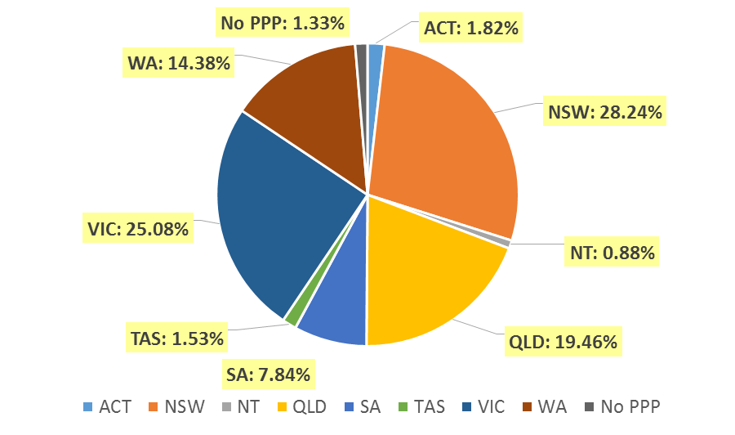

Age Group
- Registration Type and Sub type
  - Registration by age group
Age Group | General | Provisional | Limited |  | Non-practising | Total
Age Group | General | Provisional | Postgraduate training or supervised practice | Teaching or research | Non-practising | Total
U - 25 | 1,684 |  | 8 |  | 10 | 1,702
25 - 29 | 4,205 |  | 32 |  | 162 | 4,399
30 - 34 | 3,605 | 3 | 23 |  | 177 | 3,808
35 - 39 | 2,819 | 8 | 15 |  | 105 | 2,947
40 - 44 | 2,063 | 11 | 8 | 1 | 63 | 2,146
45 - 49 | 1,656 | 4 | 6 |  | 41 | 1,707
50 - 54 | 1,223 | 2 |  |  | 26 | 1,251
55 - 59 | 902 |  | 1 |  | 27 | 930
60 - 64 | 529 |  |  |  | 27 | 556
65 - 69 | 179 |  |  |  | 12 | 191
70 - 74 | 42 |  |  |  | 3 | 45
75 - 79 | 9 |  |  |  |  | 9
80+
Total | 18,916 | 28 | 93 | 1 | 653 | 19,691

  - Registration by age group

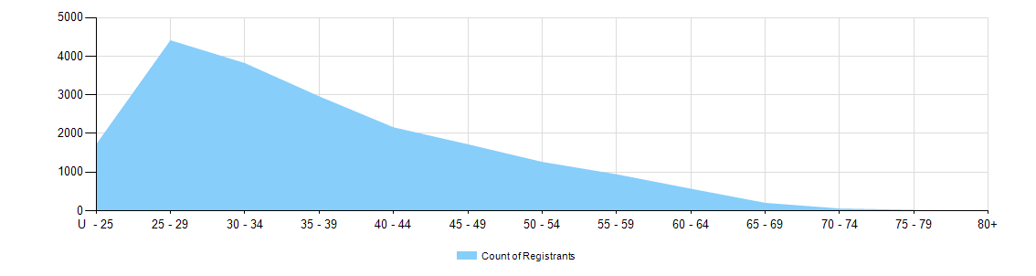

Gender
- Registration Type
  - Gender by state and territory by registration type
Gender | Registration Type | Sub Type | ACT | NSW | NT | QLD | SA | TAS | VIC | WA | No PPP | Total
Female | General |  | 309 | 4,850 | 149 | 3,358 | 1,300 | 264 | 4,363 | 2,460 | 184 | 17,237
Female | Provisional |  | 1 | 10 |  | 1 | 2 |  | 8 | 4 |  | 26
Female | Limited | Postgrad training or supervised practice | 3 | 40 | 1 | 12 | 3 |  | 17 | 14 |  | 90
Female | Limited | Teaching or research | 1 |  |  |  |  |  |  |  |  | 1
Female | Non-practising |  | 5 | 127 | 4 | 124 | 65 | 8 | 118 | 104 | 62 | 617
Total Female |  |  | 319 | 5,027 | 154 | 3,495 | 1,370 | 272 | 4,506 | 2,582 | 246 | 17,971
Male | General |  | 37 | 493 | 18 | 307 | 162 | 27 | 395 | 228 | 12 | 1,679
Male | Provisional |  |  |  |  |  | 1 |  |  | 1 |  | 2
Male | Limited | Postgrad training or supervised practice |  | 1 |  | 2 |  |  |  |  |  | 3
Male | Non-practising |  |  | 9 |  | 7 | 3 |  | 10 | 4 | 3 | 36
Total Male |  |  | 37 | 503 | 18 | 316 | 166 | 27 | 405 | 233 | 15 | 1,720
Total |  |  | 356 | 5,530 | 172 | 3,811 | 1,536 | 299 | 4,911 | 2,815 | 261 | 19,691

- Percentage
  - Registrants by gender percentages
Gender | ACT | NSW | NT | QLD | SA | TAS | VIC | WA | No PPP | Total
Female | 89.6% | 90.9% | 89.5% | 91.7% | 89.2% | 91.0% | 91.8% | 91.7% | 94.3% | 91.3%
Male | 10.4% | 9.1% | 10.5% | 8.3% | 10.8% | 9.0% | 8.2% | 8.3% | 5.7% | 8.7%

