

Occupational Therapy Board of Australia

Registrant Data

Reporting period: 1 April 2016 – 30 June 2016

Table of contents
Introduction 3
Principal Place of Practice 4
1. Registration Type 4
Age Group 5
2. Registration Type and Sub type 5
Gender 6
3. Registration Type 6
4. Percentage 6

Introduction
The role of the Occupational Therapy Board of Australia (the Board) include:
- registering occupational therapists and students
- developing standards, codes and guidelines for the occupational therapy profession
- handling notifications, complaints, investigations and disciplinary hearings
- overseeing the assessment of overseas trained practitioners who wish to practise in Australia, and
- approving accreditation standards and accredited courses of study.
The Board’s functions are supported by the Australian Health Practitioner Regulation Agency (AHPRA). For information about legislation governing our operations see About AHPRA at http://www.ahpra.gov.au/About-AHPRA/What-We-Do/Legislation.aspx.
The Board has analysed its registration data and produced a number of statistical breakdowns about registrants to share with the profession and community. The Board shares these breakdowns regularly.
For more information on occupational therapy registration, please see the Board’s website http://www.occupationaltherapyboard.gov.au/Registration.aspx

Principal Place of Practice
- Registration Type
  - Registration type by principal place of practice
Registration Type | Registration Sub-type | ACT | NSW | NT | QLD | SA | TAS | VIC | WA | No PPP | Total
General |  | 325 | 5,004 | 173 | 3,395 | 1,356 | 271 | 4,365 | 2,507 | 156 | 17,552
Provisional |  | 3 | 15 |  | 6 | 3 |  | 9 | 4 |  | 40
Limited | Postgraduate training or supervised practice | 2 | 16 |  | 17 | 3 | 1 | 21 | 9 |  | 69
Non-practising |  | 5 | 132 | 2 | 126 | 68 | 13 | 126 | 106 | 65 | 643
Total |  | 335 | 5,167 | 175 | 3,544 | 1,430 | 285 | 4,521 | 2,626 | 221 | 18,304

  - Registration type by principal place of practice percentages

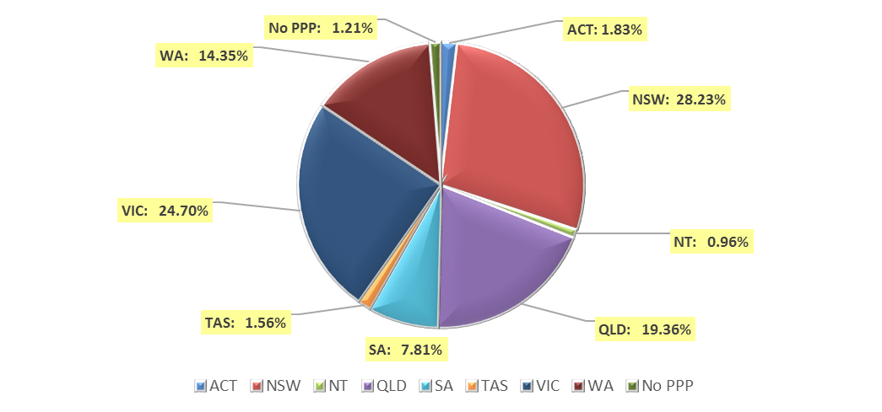

Age Group
- Registration Type and Sub type
  - Registration by age group
Age Group | General | Provisional | Limited | Non-practising | Total
Age Group | General | Provisional | Postgraduate training or supervised practice | Non-practising | Total
U - 25 | 1,765 |  | 1 | 11 | 1,777
25 - 29 | 3,828 | 2 | 21 | 173 | 4,024
30 - 34 | 3,372 | 2 | 21 | 171 | 3,566
35 - 39 | 2,575 | 15 | 13 | 107 | 2,710
40 - 44 | 1,910 | 11 | 5 | 57 | 1,983
45 - 49 | 1,490 | 6 | 3 | 33 | 1,532
50 - 54 | 1,127 | 1 | 3 | 30 | 1,161
55 - 59 | 857 | 3 | 1 | 24 | 885
60 - 64 | 439 |  | 1 | 22 | 462
65 - 69 | 156 |  |  | 12 | 168
70 - 74 | 31 |  |  | 3 | 34
75 - 79 | 2 |  |  |  | 2
80+
Total | 17,552 | 40 | 69 | 643 | 18,304

  - Registration by age group

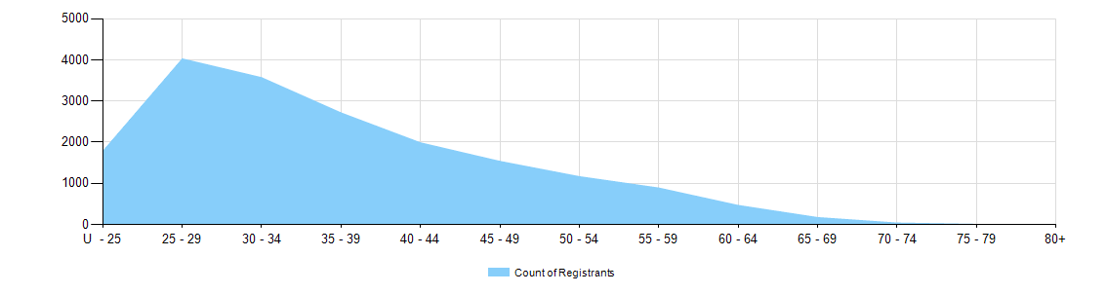

Gender
- Registration Type
  - Gender by state and territory by registration type
Gender | Registration Type | Sub Type | ACT | NSW | NT | QLD | SA | TAS | VIC | WA | No PPP | Total
Female | General |  | 286 | 4,557 | 155 | 3,126 | 1,205 | 247 | 4,009 | 2,301 | 147 | 16,033
Female | Provisional |  | 3 | 15 |  | 6 | 3 |  | 8 | 4 |  | 39
Female | Limited | Postgrad training or supervised practice | 2 | 13 |  | 17 | 1 | 1 | 18 | 8 |  | 60
Female | Non-practising |  | 5 | 125 | 2 | 121 | 65 | 13 | 120 | 104 | 62 | 617
Total Female |  |  | 296 | 4,710 | 157 | 3,270 | 1,274 | 261 | 4,155 | 2,417 | 209 | 16,749
Male | General |  | 39 | 447 | 18 | 269 | 151 | 24 | 356 | 206 | 9 | 1,519
Male | Provisional |  |  |  |  |  |  |  | 1 |  |  | 1
Male | Limited | Postgrad training or supervised practice |  | 3 |  |  | 2 |  | 3 | 1 |  | 9
Male | Non-practising |  |  | 7 |  | 5 | 3 |  | 6 | 2 | 3 | 26
Total Male |  |  | 39 | 457 | 18 | 274 | 156 | 24 | 366 | 209 | 12 | 1,555
Total |  |  | 335 | 5,167 | 175 | 3,544 | 1,430 | 285 | 4,521 | 2,626 | 221 | 18,304

- Percentage
  - Registrants by gender percentages
Gender | ACT | NSW | NT | QLD | SA | TAS | VIC | WA | No PPP | Total
Female | 88.4% | 91.2% | 89.7% | 92.3% | 89.1% | 91.6% | 91.9% | 92% | 94.6% | 91.5%
Male | 11.6% | 8.8% | 10.3% | 7.7% | 10.9% | 8.4% | 8.1% | 8% | 5.4% | 8.5%

